**aaZAssignment 3**

**/\*\*\*\*\*\*\*\*\*\*\*\*\*\*\*\*\*\*\*\*\*\*\*\*\*\*\*\*\*\*\*\*\*\*\*\*\*\*\*\*\*\*\*\*\*\*\***

**\*\* File: Assignment3.sql**

**\*\* Desc: Manipulating, Categorizing, Sorting and Grouping & Summarizing Data**

**\*\* Author: Swati Susan Sathyan**

**\*\* Date:10/14/2023**

**\*\*\*\*\*\*\*\*\*\*\*\*\*\*\*\*\*\*\*\*\*\*\*\*\*\*\*\*\*\*\*\*\*\*\*\*\*\*\*\*\*\*\*\*\*\*\*\*/**

**QUESTION 1**

1. **Show the list of databases.**

1. **Select sakila database.**

1. **Show all tables in the sakila database.**

1. **Show each of the columns along with their data types for the actor table.**

1. **Show the total number of records in the actor table.**

1. **What is the first name and last name of all the actors in the actor table ?**

1. **Insert your first name and middle initial ( in the last name column ) into the actors table.**

1. **Update your middle initial with your last name in the actors table.**

1. **Delete the record from the actor table where the first name matches your first name.**

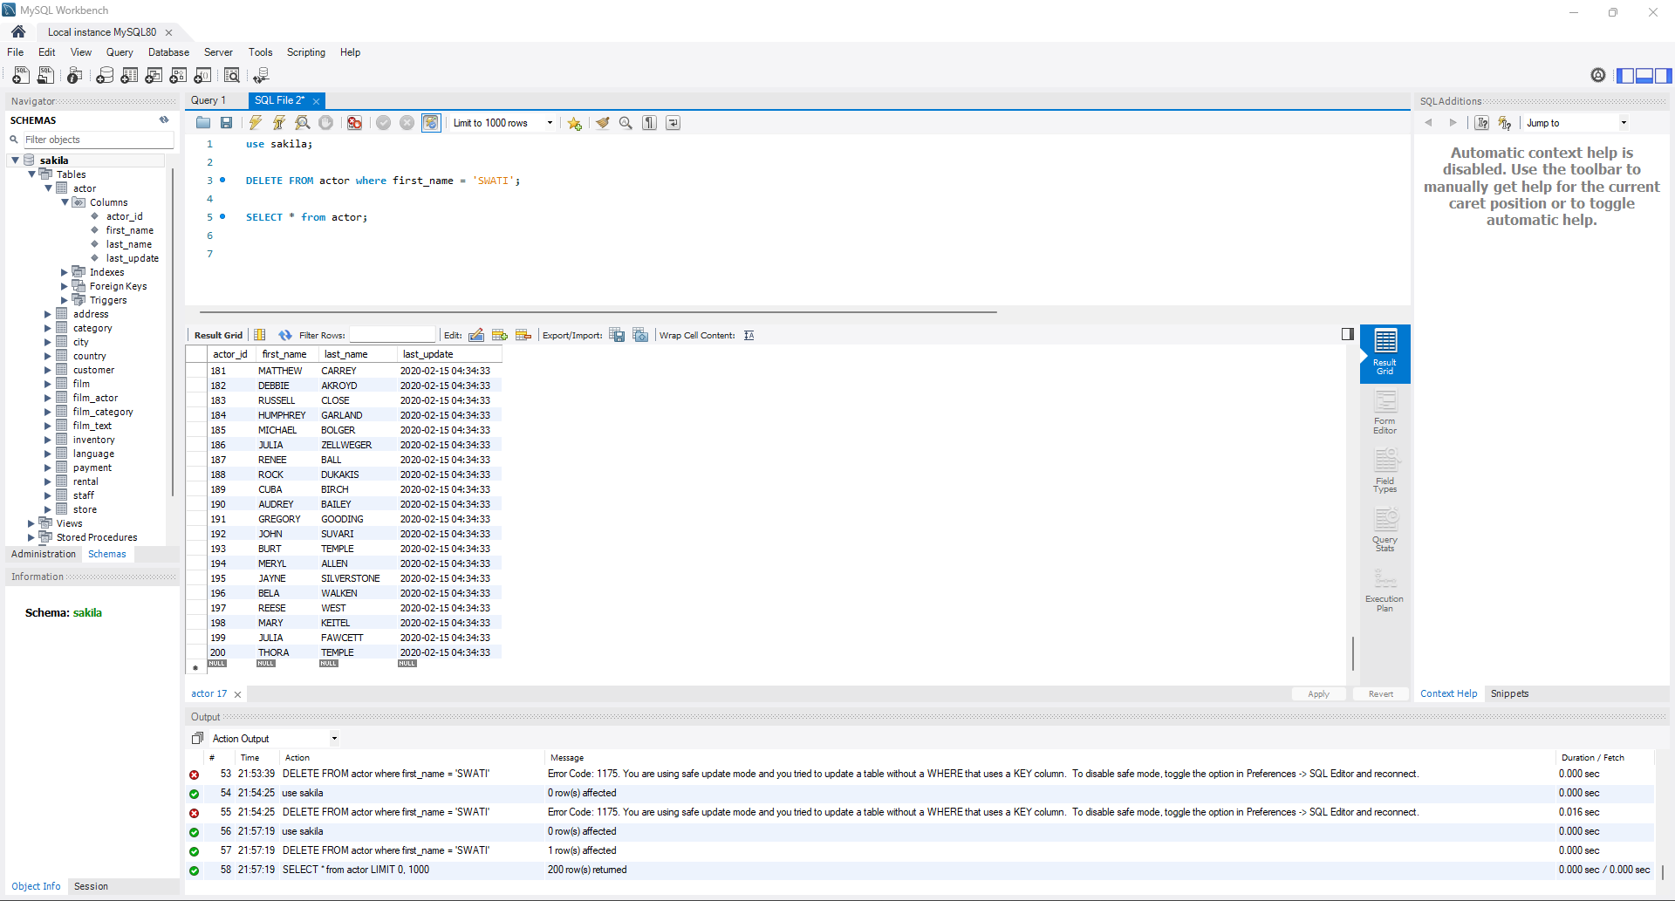

**j) Create a table payment_type with the following specifications and appropriate data types**

**Table Name : “Payment_type”**

**Primary Key: "payment_type_id”**

**Column: “Type”**

**Insert following rows in to the table:**

**1, “Credit Card” ; 2, “Cash”; 3, “Paypal” ; 4 , “Cheque”**

1. **Rename table payment_type to payment_types.**

1. **Drop the table payment_types.**

**QUESTION 2**

1. **List all the movies ( title & description ) that are rated PG-13 ?**

1. **List all movies that are either PG OR PG-13 using IN operator ?**

**c) Report all payments greater than and equal to 2$ and Less than equal to 7$ ?**

**Note : write 2 separate queries conditional operator and BETWEEN keyword**

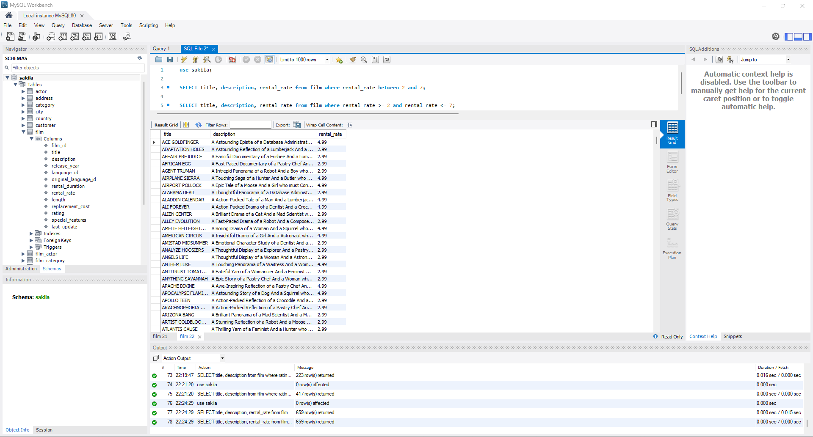

1. **List all addresses that have phone number that contain digits 589, start with 140 or end with 589**

1. **List all staff members ( first name, last name, email ) whose password is NULL ?**

1. **Select all films that have title names like ZOO and rental duration greater than or equal to 4**

**g) What is the cost of renting the movie ACADEMY DINOSAUR for 2 weeks ?**

**Note : use of column alias**

**h) List all unique districts where the customers, staff, and stores are located**

**Note : check for NOT NULL values**

1. **List the top 10 newest customers across all stores**

**QUESTION 3**

1. **Show total number of movies**

1. **What is the minimum payment received and max payment received across all transactions ?**

1. **Number of customers that rented movies between Feb-2019 & May-2019 ( based on paymentDate ).**

1. **List all movies where replacement_cost is greater than 15$ or rental_duration is between 6 & 10 days**

1. **What is the total amount spent by customers for movies in the year 2019 ?**

1. **What is the average replacement cost across all movies ?**

1. **What is the standard deviation of rental rate across all movies ?**

**h) What is the midrange of the rental duration for all movies**

**QUESTION 4**

1. **Customers sorted by first Name and last name in ascending order.**

1. **Count of movies that are either G/NC-17/PG-13/PG/R grouped by rating.**

1. **Number of addresses in each district.**

1. **Find the movies where rental rate is greater than 1$ and order result set by descending order.**

1. **Top 2 movies that are rated R with the highest replacement cost?**

1. **Find the most frequently occurring (mode) rental rate across products.**

**g) Find the top 2 movies with a movie length greater than 50 mins and which have commentaries as special**

**features.**

**# h) List the years which has more than 2 movies released.**

